Hackathon

Team Tech wizards

Contents

Team details 2

Problem statement 3

Solution 3

Annexure 4

Github repo 4

Team contact details 4

## Team details

|  |  |  |
| --- | --- | --- |
| **Sr. No.** | **Team Member** | **Role** |
| 1 | Nidhi Gadhari | Team Lead |
| 2 | Prashanthi Arra | Team Lead |
| 3 | Pooja Jagtap | Developer |
| 4 | Prathamesh Karatkar | Developer |
| 5 | Rakesh Marri | Developer |
| 6 | Razique Shaikh | Developer |
| 7 | Yash raj Vardhan | Developer |
| 8 | Vaishnavi Kudmethe | Cloud Engineer |
| 9 | Amir Rajesaheb Shaikh | Cloud Engineer |
| 10 | Umar Pinjari | Cloud Engineer |

## Problem statement

Yoga or Fitness

## Solution

Created a Website for Awareness

## Description

We created a Yoga or Fitness website with HTML, CSS for creating Awarenesss

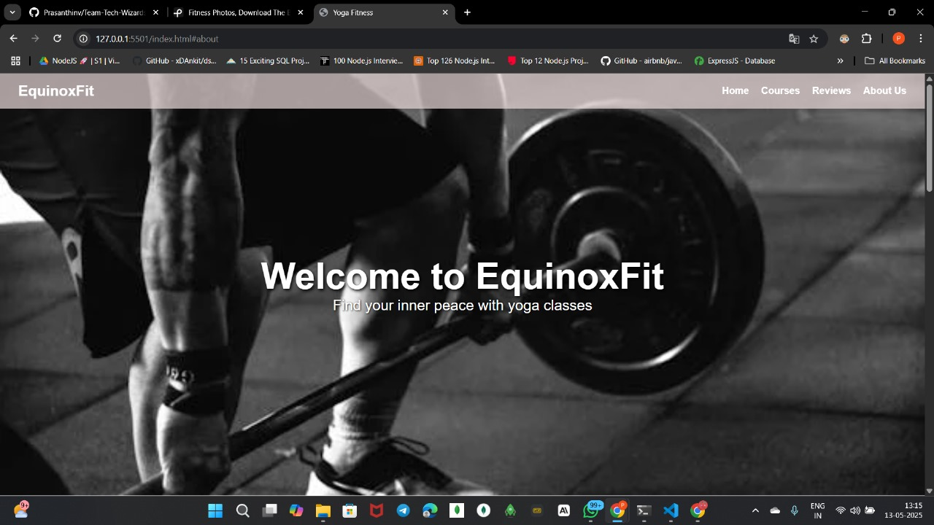

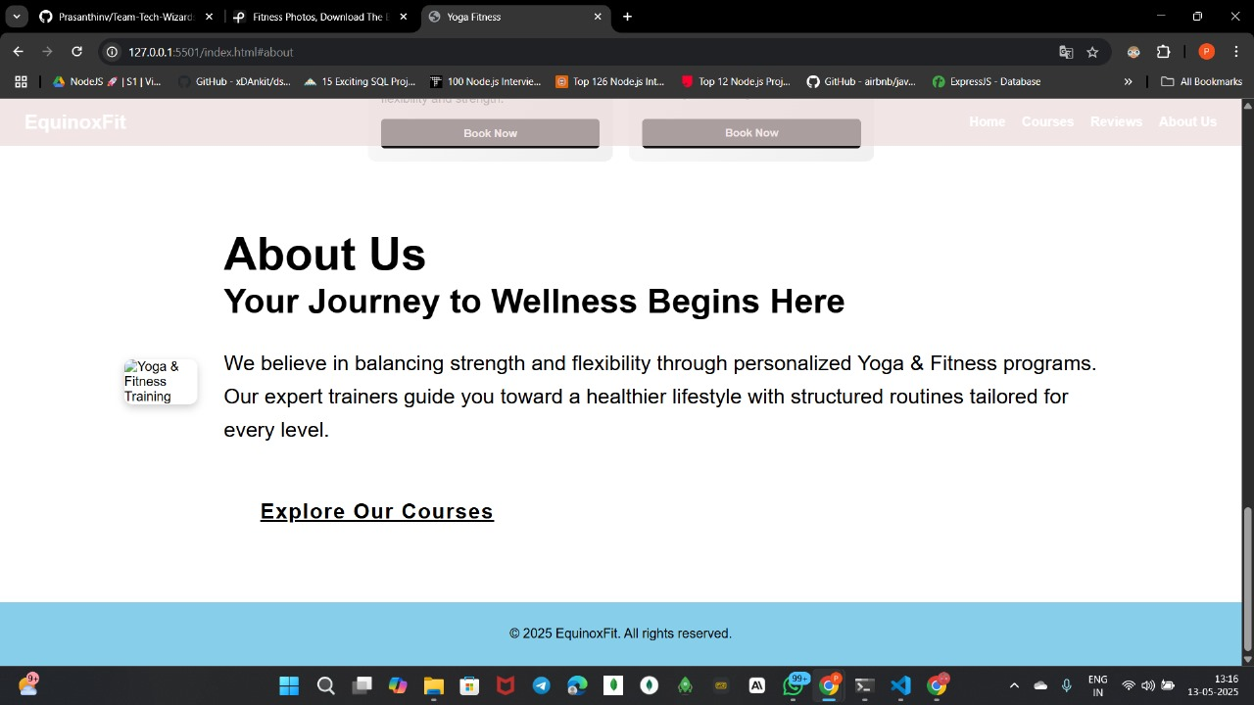

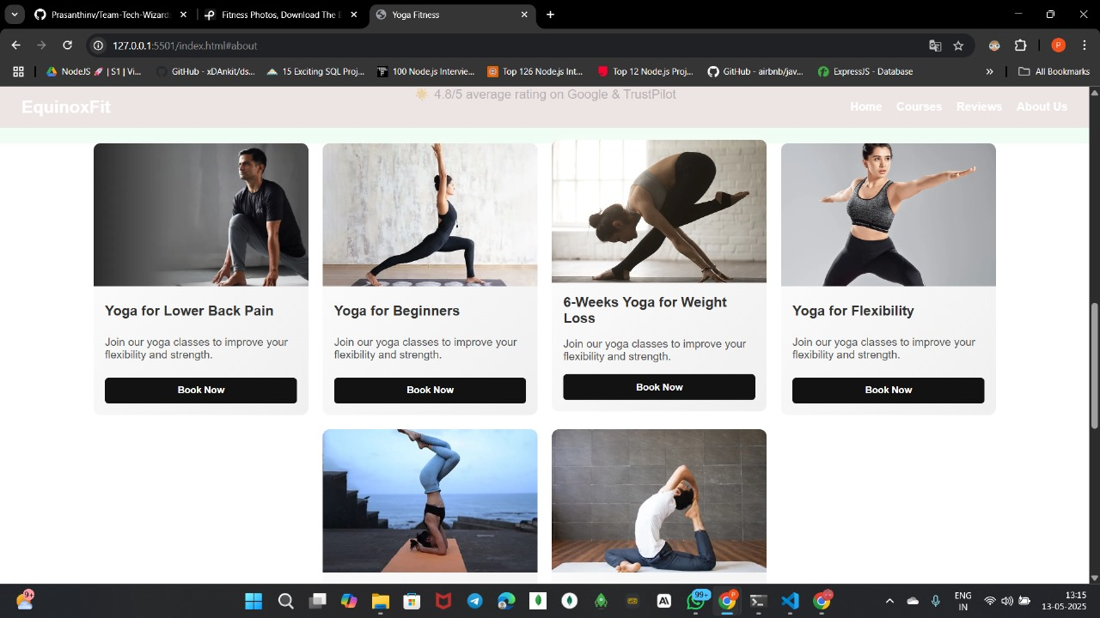

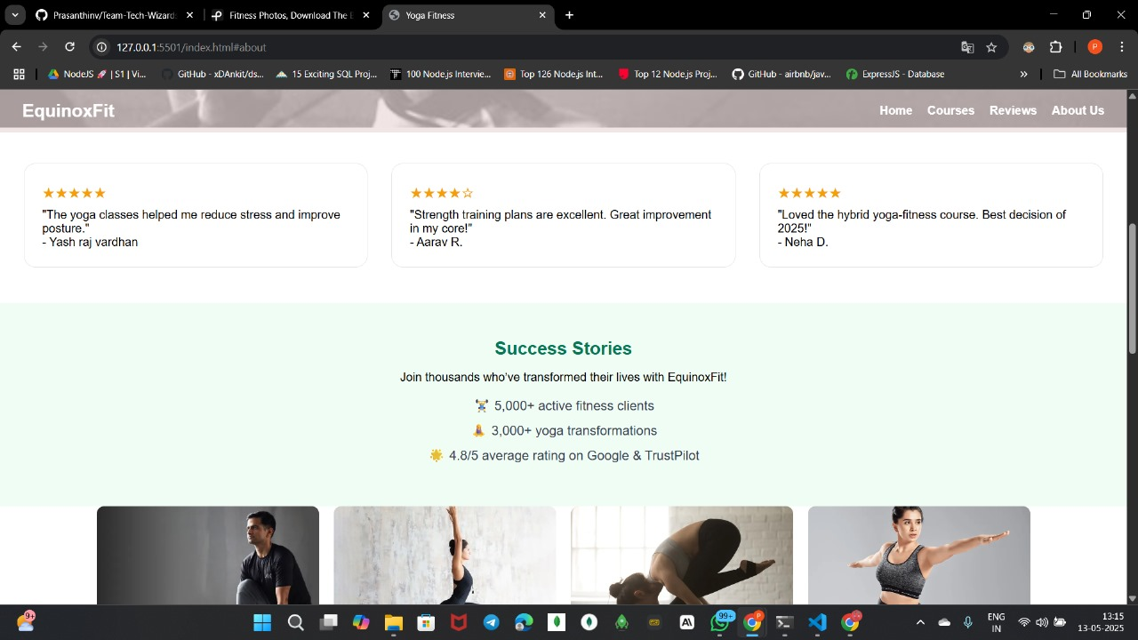

Source code- <https://github.com/Prasanthinv/Team-Tech-Wizards>

Steps for Deployment

1. Service tab -> storage->select S3

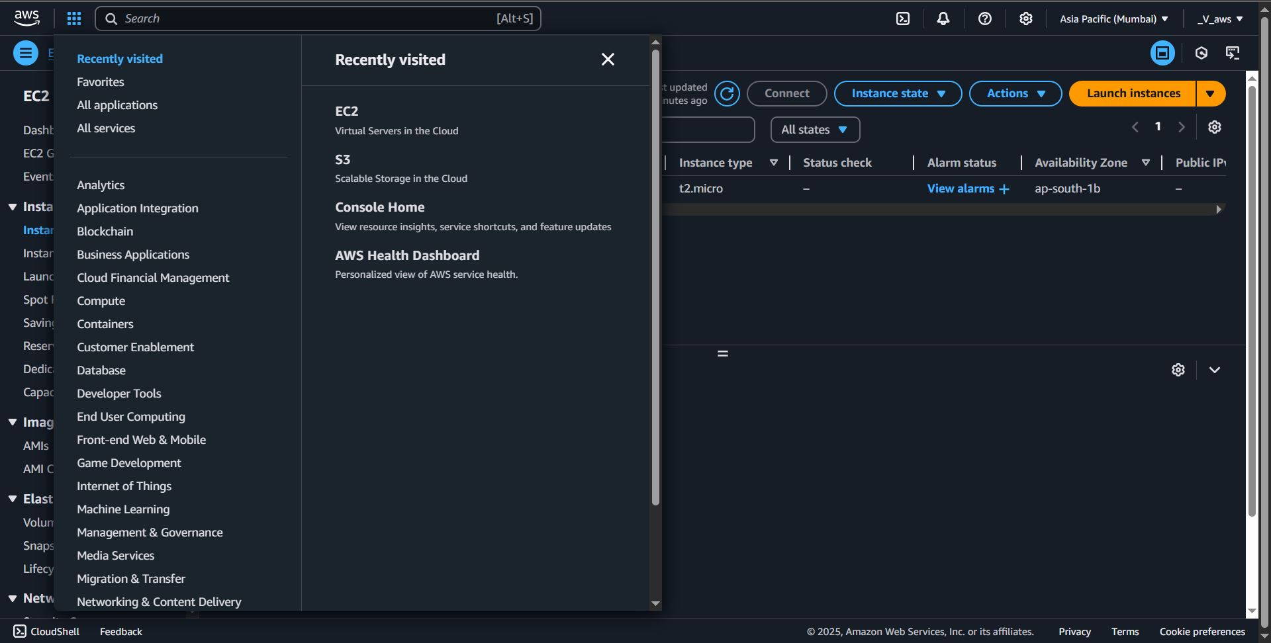

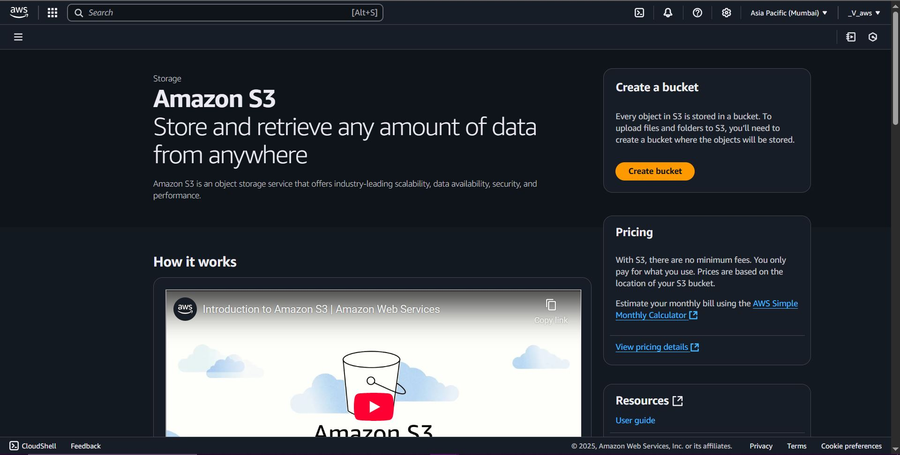

1. create bucket ->Give unique name -> create bucket
2. select bucket name-> upload->add files->browse project files select and open them->upload->close the window
3. edit bucket policies->click on generate policies->policy generator

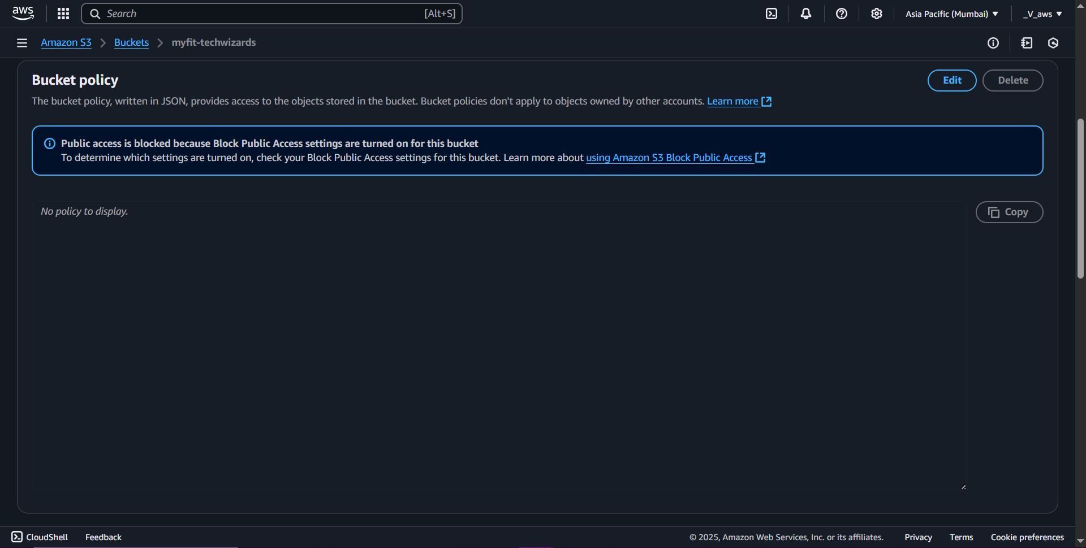

step1: select S3 bucket policies, it will open new window.

step2: principals =*->Actions = getObject-> ARN=goto console and copy paste the ARN->Add statement

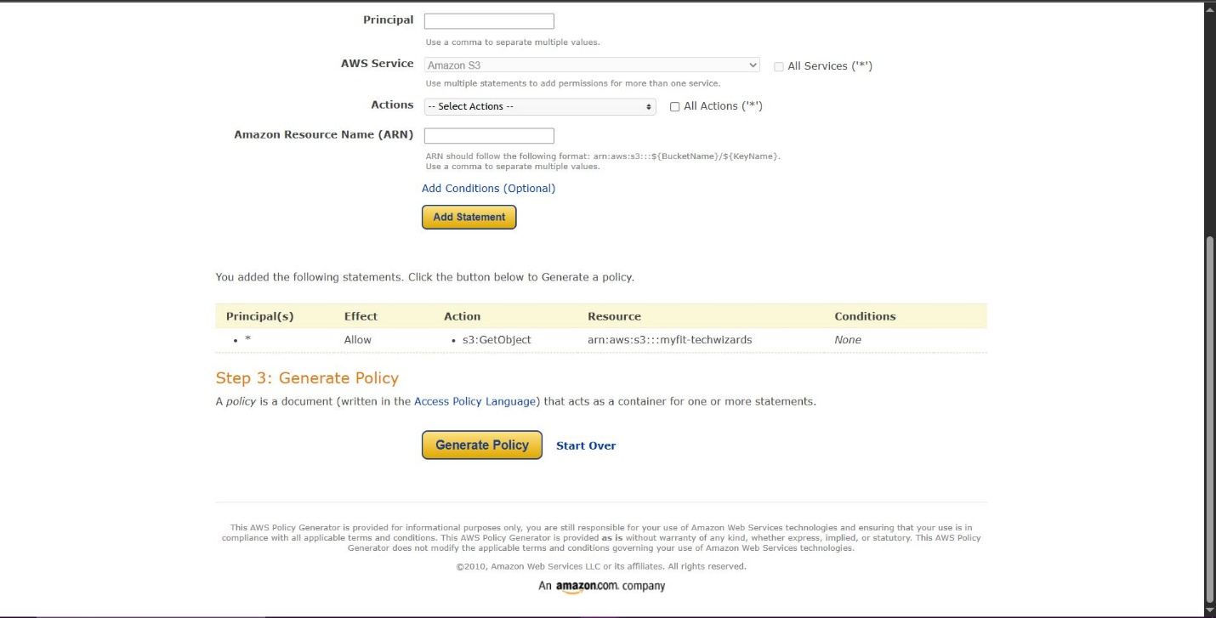

step3: click on generate policies->copy the json code

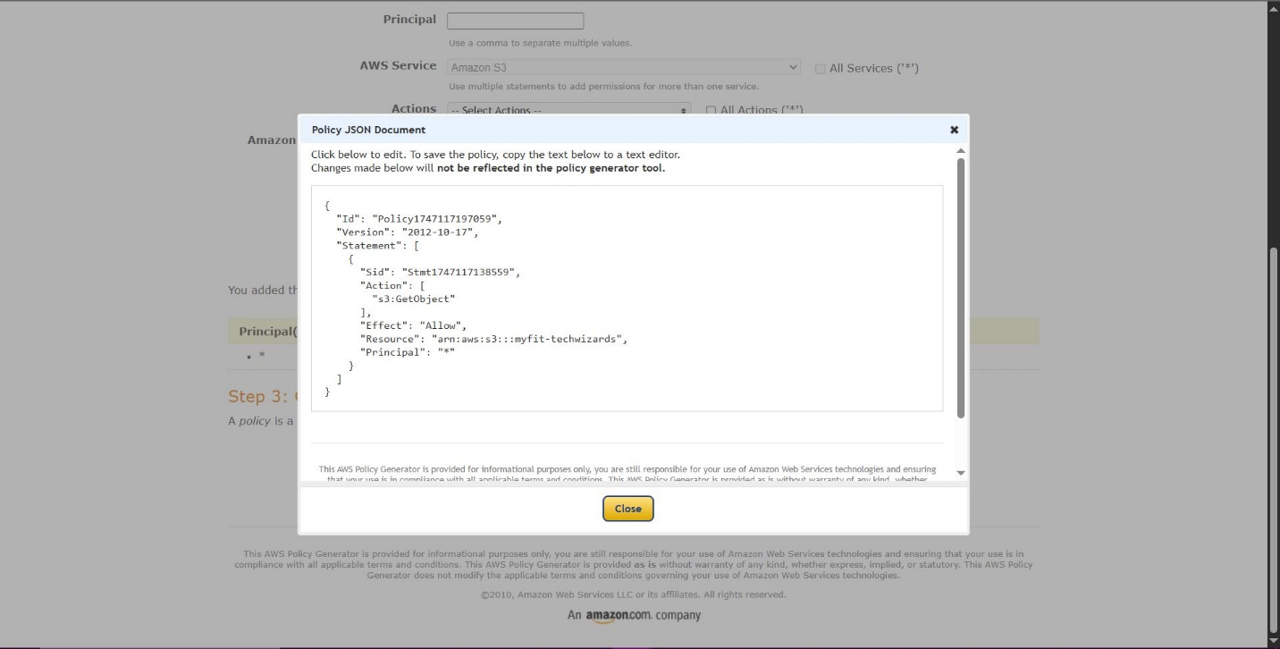

1. paste copied json code in bucket policy textbox->Save changes

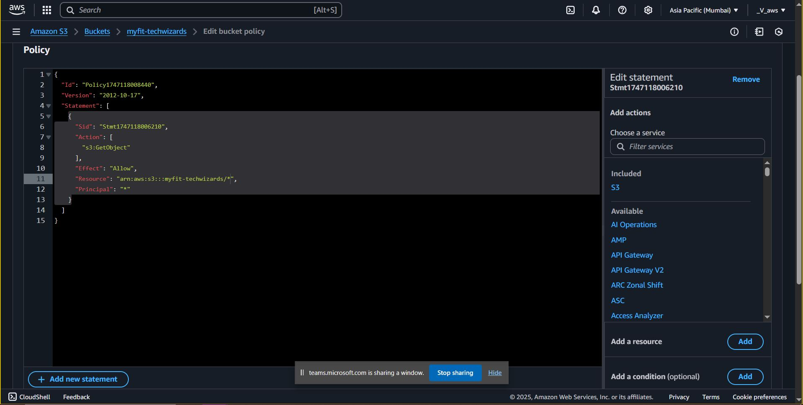

1. it will showing error then edit resource value add /* in the end within quotes-> save changes

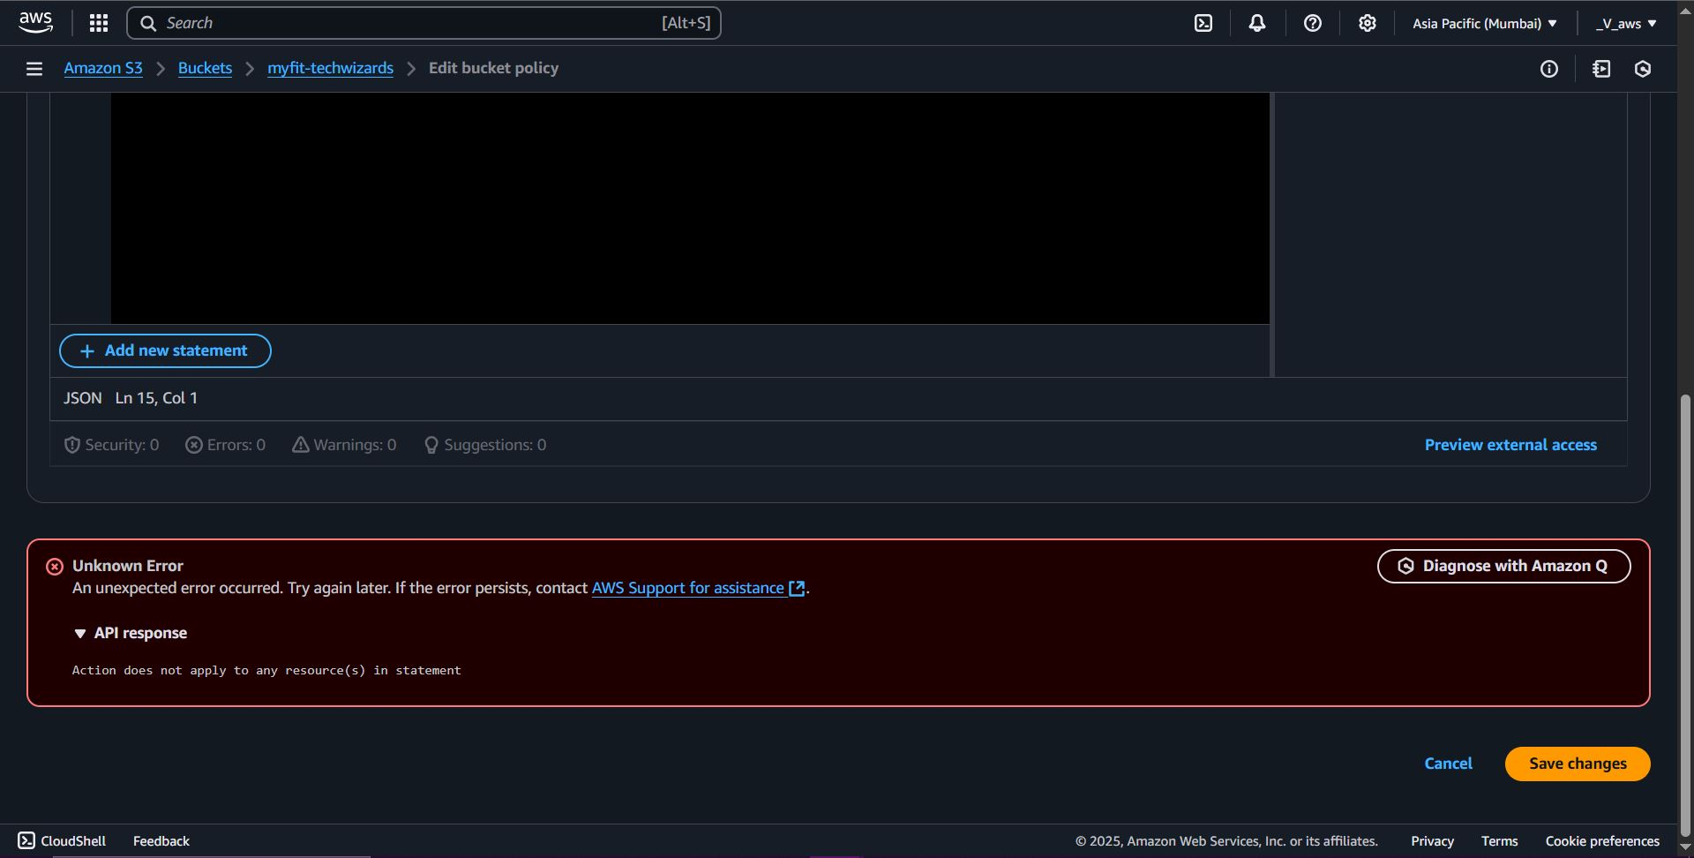

1. goto property-> enable static website fill index.html and error.html in text field and save
2. copy the URL from the the page bottom and paste in browser’s tab
3. It will not show any html page because we keep selected the block public access which means the website is not accessible for the public which means the bucket objects are private by default.
4. Click on the bucket name ->permission->edit the block public access->unselect the block public access->save changes.

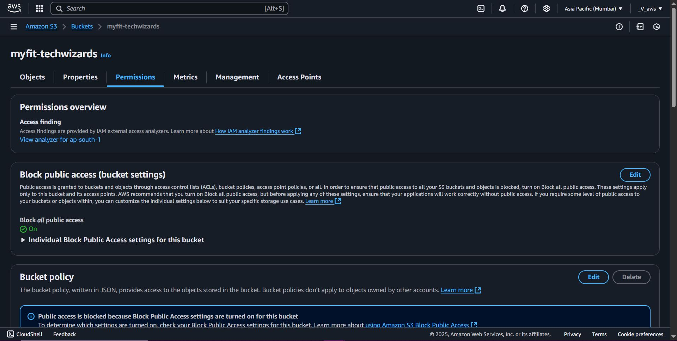

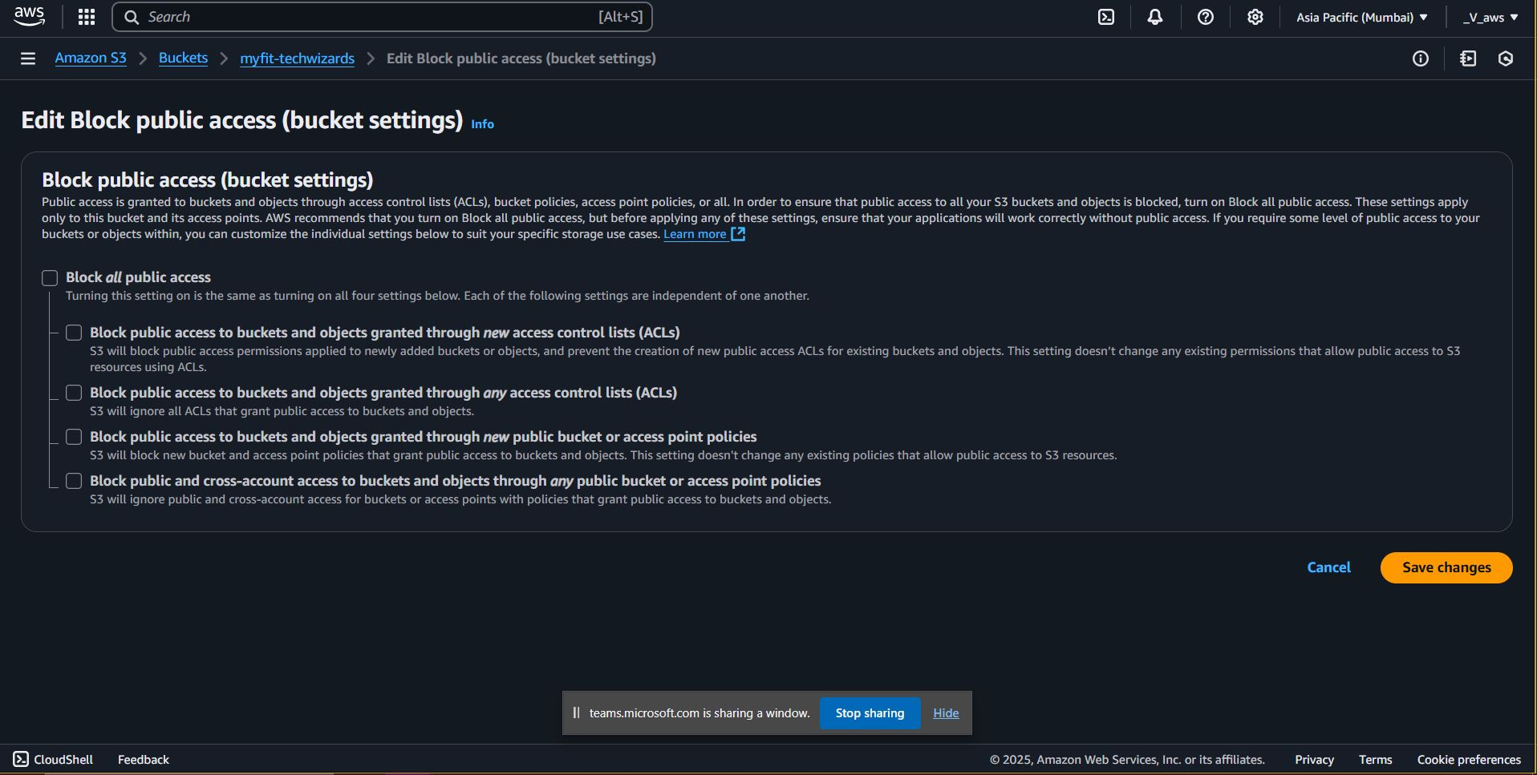

## Annexure

### Github repo

### Team contact details

|  |  |  |  |  |
| --- | --- | --- | --- | --- |
| **Sr. No.** | **Team Member** | **Emaild ID** | **Phone no.** | **Github Repo** |
| 1 | Nidhi Gadhari | gadharinidhi@gmail.com | 9916731718 | https://github.com/NidhiGadhari |
| 2 | Prashanthi Arra | prasanthi.smiley@gmail.com | 7034942335 | https://github.com/Prasanthinv |
| 3 | Pooja Jagtap | poojajagtap0623@gmail.com | 9373245103 | https://github.com/jagtap-pooja77 |
| 4 | Prathamesh Karatkar | prathameshkaratkar2224@gmail.com | 9130457501 | https://github.com/prathameshkaratkar |
| 5 | Rakesh Marri | marrirakesh231@gmail.com | 9347460903 | https://github.com/Rakesh123-pr |
| 6 | Razique Shaikh | razikshaikh5251@gmail.com | 7499482433 | https://github.com/razik-shaikh |
| 7 | Yashraj Vardhan | yash707088@gmail.com | 9155868789 | https://github.com/Yashrajvardhan |
| 8 | Amir Rajesaheb Shaikh | 786amirshk@gmail.com | 9284840608 | https://github.com/Amirshk08 |
| 9 | Umar Pinjari | Not Provided | Not provided | Not provided |
| 10 | Vaishnavi Kudmethe | vaishnavikudmethe13@gmail.com | 9370822496 | https://github.com/vaishnavikudmethe |